**Goal:**

The goal of this problem is to predict the Price of a refurbished car based on the variables provided in the data set.

**Metric to measure**

The measure of accuracy will be RMSLE (root mean squared logarithmic error). The predicted Price for each car in the Test dataset will be compared with the actual Price to calculate the RMSLE value of the entire prediction. The lower the RMSLE value, the better the model will be.

Mathematical definition of Root Mean Squared Logarithmic Error:

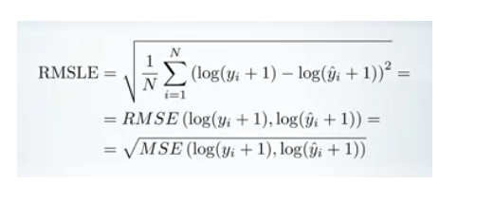

Here, yi refers to the actual Price of the cars and y^  ( y-hat) refers to the estimated Price. ‘N’ is the number of observations of the test data set.

**Submission File Format:**

You are to submit a csv file with exactly 5615 entries plus a header row. The file should have exactly two columns

1. ID
2. Price